Question 1:
Create a program that validates password strength based on these rules:
- At least 8 characters long
- Contains at least one uppercase letter
- Contains at least one digit
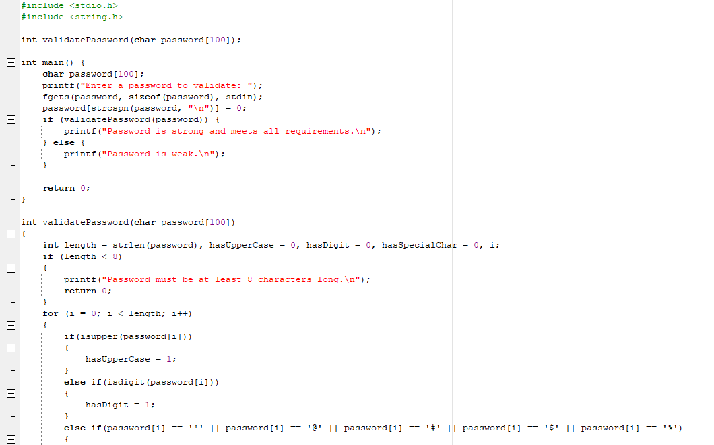
- Contains at least one special character (!, @, #, $, %)
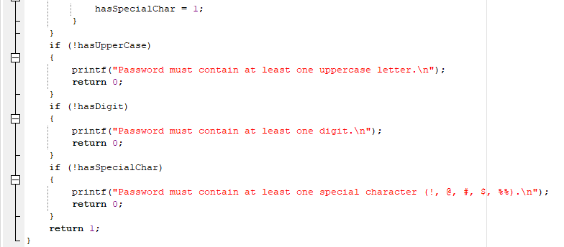
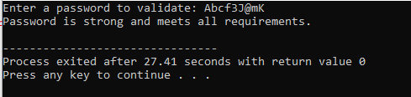
Question 2:
Write a program that extracts and displays the domain from email addresses.
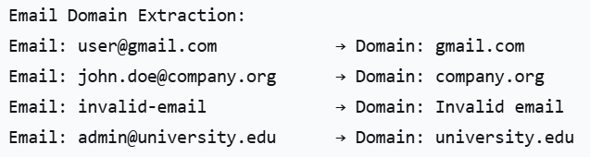
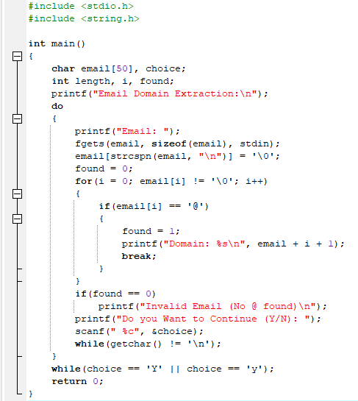
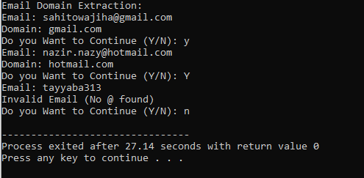
Question 3:
Write a program that counts vowels, consonants, digits, and spaces in a string.
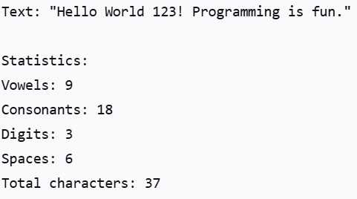
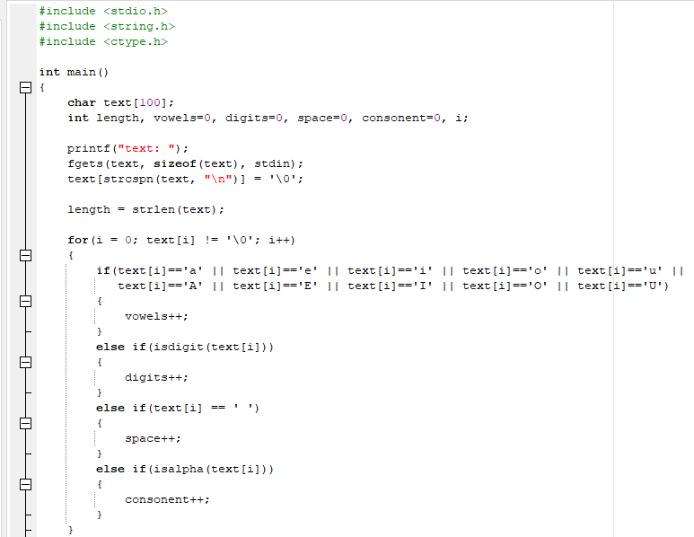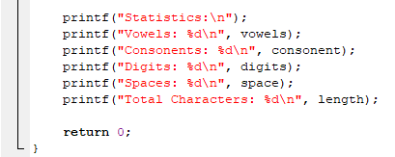
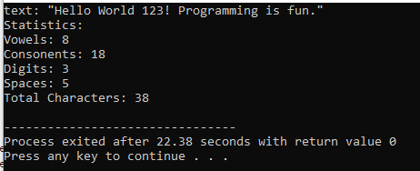

Question 4:
Create a program that encrypts a message by shifting each letter by 3 positions.
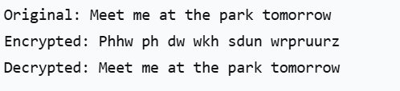
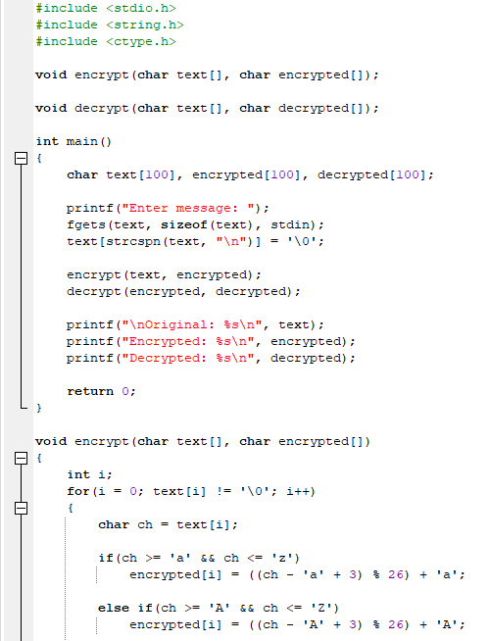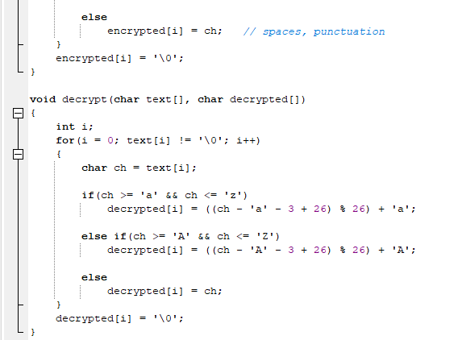

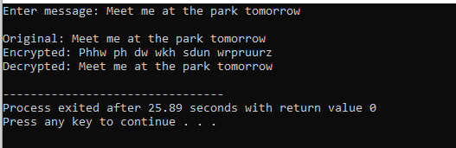
Question 5:
Create a program that stores student names and marks, then finds the highest scorer.
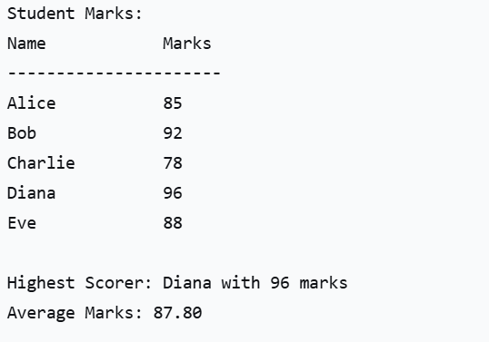
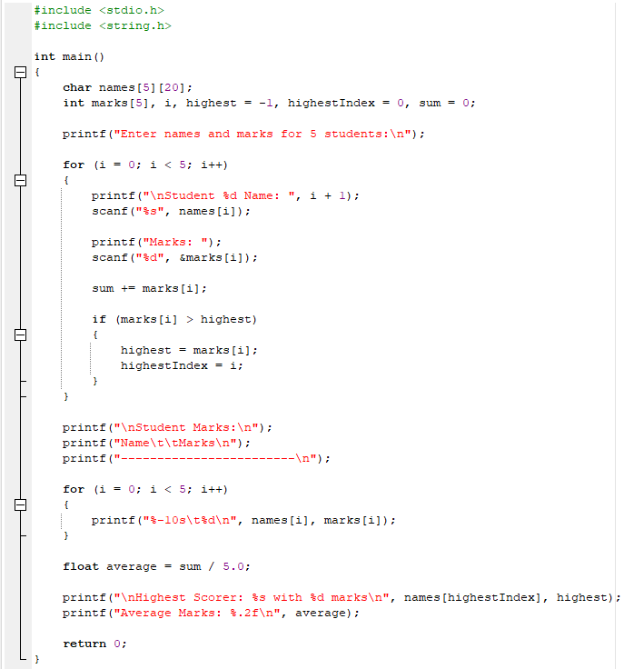
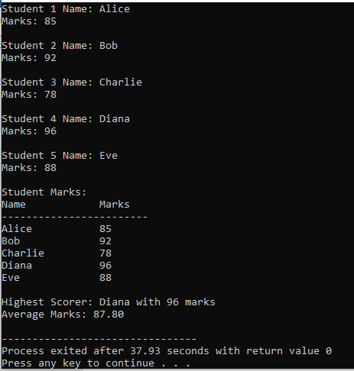
Question 6:
You are a teacher who needs to manage student marks for a class. You have 5 students in your class, each with their name and test marks. You want to create a program that:
- Shows a list of all students with their marks in a neat table
- Finds the top student - who got the highest marks in the test
- Calculates the class average - the average marks of all students

How the program works:
- It stores student names like "Alice", "Bob", "Charlie" etc.
- It stores their corresponding marks like 85, 92, 78 etc.
- It displays everything in a clean table format
- It goes through all marks to find which student has the highest score
- It adds up all marks and divides by number of students to find average
You write down all student names and their scores, then you figure out who got the highest marks and what the class average was.
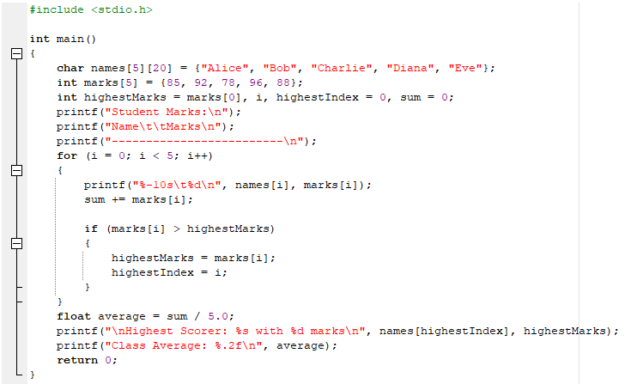
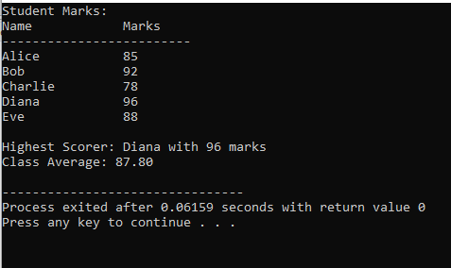

Question 7:
You are a school administrator managing student course registrations. You have 4 students who have signed up for different courses. The program should:
- Show each student's registered courses - display what courses each student is taking
- Find students taking a specific course - like finding all students taking Physics
- Identify overloaded students - find students who registered for too many courses (more than 3)
How the program works:
- It stores student names: Alice, Bob, Charlie, Diana
- Each student has a list of courses they registered for
- Some students have fewer courses, some have more
- It can search through all students' courses to find who is taking a particular subject
- It counts how many courses each student has and flags those with too many
Imagine you're a college advisor. Students come to you with their course selection forms. You need to check who's taking which courses and make sure no student is taking too many classes at once.
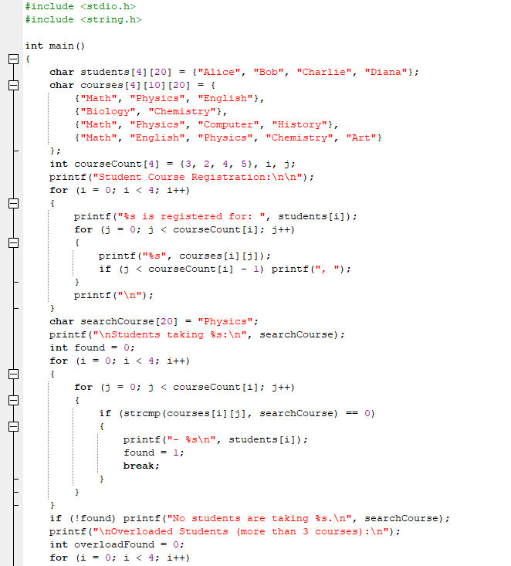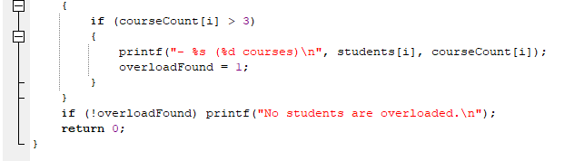
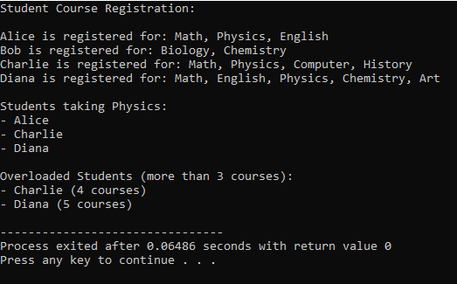
Question 8:
You own a restaurant and want to create a digital menu for your customers. Your menu has 3 categories (Appetizers, Main Course, Desserts) with 3 items in each category. The program should:
- Display the complete menu organized by categories
- Show budget-friendly options - find all items that cost less than $10
- Format everything neatly so it's easy for customers to read
How the program works:
- It stores menu categories: Appetizers, Main Course, Desserts
- Each category has food items with prices
- It displays the menu in sections with clear headings
- It goes through all prices to find items that cost less than $10
- It shows which category each budget item belongs to
Imagine you're looking at a restaurant menu. The menu is divided into sections (starters, main dishes, desserts). You might look for the cheaper items if you're on a budget.
